Assignment – 3
Course Title : Introduction to Database Course Code : IT244
Due Date: 17 December, 2016
Q. 1 Normalize the following schema, with given constraints, to BCNF. (2 Point)
books(accessionn, isbn, title, author, publisher)
users(userid, name, deptid, deptname)

F= { accessionno isbn
isbn title
isbn publisher
isbn author
userid name
userid deptid
deptid deptname}

Q. 2 Consider the relational database given below, where the primary keys are underlined.
Give an expression in Tuple Relational Calculus and Domain Relational Calculus
for each of the following queries: (0.5+0.5 = 1 Point) 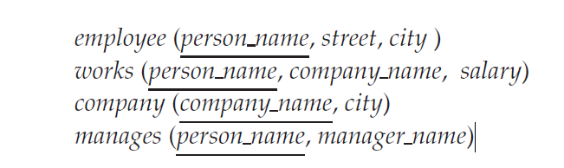
a. Find all employees who work directly for “STC”
b. Find all cities of residence of all employees who work directly for “STC”

Q. 3 Consider the following database: (0.5+0.5+1= 2 Points)
person (driver_id, name, address)
car (license, model, year)
accident (report_number, date, location)
owns (driver_id, license)
participated (report_number, license, driver_id, damage_amount)
- Write SQL DDL corresponding to the following schema. Make any reasonable assumptions about data types, and be sure to declare primary and foreign keys.
- Find the number of accidents in which the cars belonging to “John Smith” were involved.
- Update the damage amount for the car with license number “AABB2000” in the accident with report number “AR2197” to $3000.

